Week7_Conditional Rendering of Course, Book, and Blog Details using React Components (bloggerapp)

Objective:

Create a React App named “bloggerapp” in with 3 components.

1.Book Details

2.Blog Details

3.Course Details

Implement this with as many ways possible of Conditional Rendering.

Phase 1: Setting Up Your Development Environment
Step 1: Install Node.js and npm
- Explanation: Node.js is a JavaScript runtime that lets you run JavaScript on your computer. npm is the package manager for Node.js, used to install and manage project dependencies like React.
- Action:
- Open a web browser and navigate to the official Node.js download page: https://nodejs.org/en/download/
Step 2: Install Visual Studio Code
- Explanation: Visual Studio Code (VS Code) is a free, powerful code editor that is highly recommended for React development.
- Action:
- Go to the official VS Code website: https://code.visualstudio.com/
- Download and run the installer for your operating system.

Phase 2: Creating and Running the React Application
Step 3: Create the React Application
- In your command prompt or terminal, navigate to the directory where you want to store your project (e.g., your Desktop or a development folder).
- Type the following command and press Enter. This may take a few minutes to complete.
npx create-react-app bloggerapp

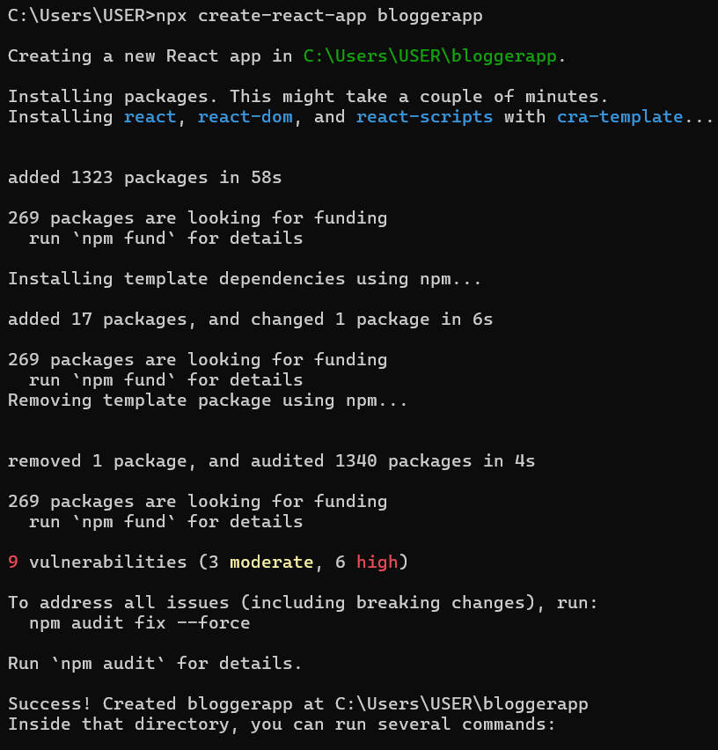
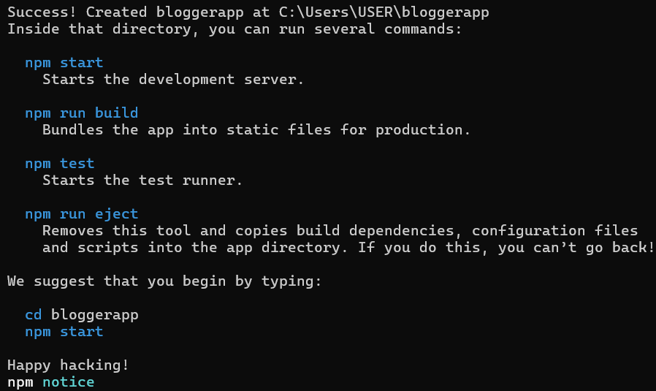
Step 4: Navigate into Your New Project Folder
- You must be inside the project folder to run commands related to this specific application.
- Once the command from Step 4 is finished, type the following command to move into the newly created directory:
cd blogapp
Step 5: Open the Project in Visual Studio Code
- This command opens the entire project folder in VS Code, allowing you to easily browse and edit the project files.
- Type the command:
code .
Note: The . tells VS Code to open the current directory.
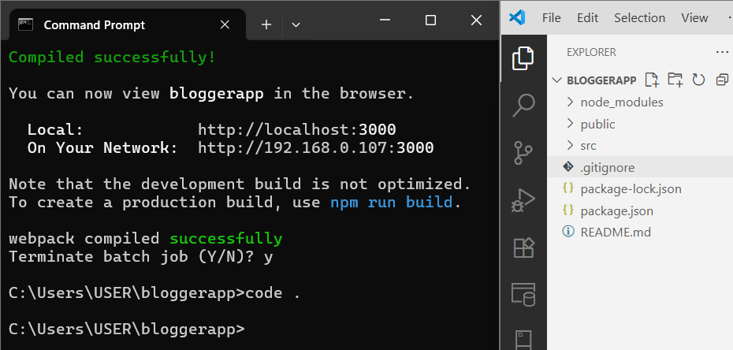
Step 6: Create the BookDetails.js File
- In the VS Code explorer, right-click the src folder.
- Select "New File" and name it BookDetails.js.
import React from 'react';
const BookDetails = ({ books }) => {
return (
<div>
<h1>Book Details</h1>
{books.map(book => (
<div key={book.id}>
<h2>{book.bname}</h2>
<p>{book.price}</p>
</div>
))}
</div>
);};
export default BookDetails;
Step 7: Create the BlogDetails.js File
- In the VS Code explorer, right-click the src folder.
- Select "New File" and name it BlogDetails.js.
import React from 'react';
const BlogDetails = () => {
return (
<div>
<h1>Blog Details</h1>
<h2>React Learning</h2>
<h3>Stephen Biz</h3>
<p>Welcome to learning React!</p>
<h2>Installation</h2>
<h3>Schwezdenier</h3>
<p>You can install React from npm.</p>
</div>
);
};
export default BlogDetails;
Step 8: Create the CourseDetails.js File
- In the VS Code explorer, right-click the src folder.
- Select "New File" and name it CourseDetails.js.
import React from 'react';
const CourseDetails = () => {
return (
<div>
<h1>Course Details</h1>
<h2>Angular</h2>
<p>4/5/2021</p>
<h2>React</h2>
<p>6/3/20201</p>
</div>
);
};
export default CourseDetails;
Step 9: Edit the Main App.js File
- Open the App.js file from the src folder.
- Replace all of its content with this code:
import React from 'react';
import BookDetails from './BookDetails';
import BlogDetails from './BlogDetails';
import CourseDetails from './CourseDetails';
import './App.css'; // import CSS
const books = [
{ id: 101, bname: 'Master React', price: 670 },
{ id: 102, bname: 'Deep Dive into Angular 11', price: 800 },
{ id: 103, bname: 'Mongo Essentials', price: 450 },
];
function App() {
const showBooks = true;
const showCourses = true;
const showBlogs = true; // Make this true to show blog section
return (
<div className="container">
{showCourses && (
<div className="section">
<CourseDetails />
</div>
)}
{showBooks && (
<div className="section border-left">
<BookDetails books={books} />
</div>
)}
{showBlogs && (
<div className="section border-left">
<BlogDetails />
</div>
)}
</div>
);
}
export default App;

Step 10: Edit the Main App.css File
.container {
display: flex;
justify-content: center;
padding: 40px;
gap: 40px;
font-family: Arial, sans-serif;
}
.section {
padding: 0 20px;
}
.border-left {
border-left: 4px solid green;
padding-left: 20px;
}
h1, h2, h3 {
font-weight: bold;
margin-bottom: 10px;
}
p {
margin: 5px 0;
}
Step 11: Run the Application
- Go back to your terminal (it should still be in the bloggerapp folder).
- Run the start command:
npm start

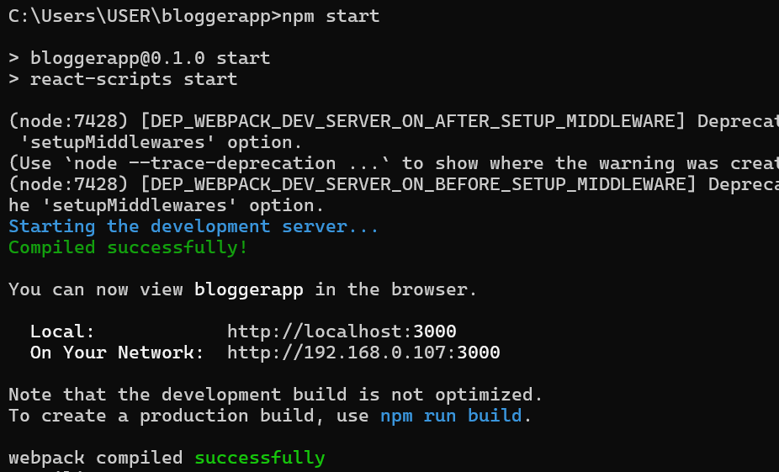
Step 12: View Your Application
- The development server hosts your application on a local port, typically 3000.
Local: http://localhost:3000
On Your Network: http://192.168.0.107:3000

Output:

